FFA Holiday Apparel – Individual Form
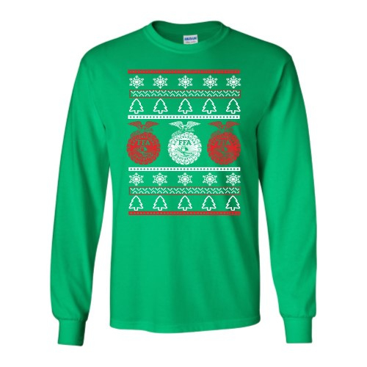

Item | Size/ Quantity | Total
T – Shirt | S M L XL 2XL 3XL 4XL  $10 $10 $10 $10 $14 $14 $14
Crew Neck Sweatshirt | S M L XL 2XL 3XL 4XL  $18 $18 $18 $18 $22 $22 $22
Cotton Long Sleeve | S M L XL 2XL 3XL 4XL  $18 $18 $18 $18 $22 $22 $22
Hooded Sweatshirt | S M L XL 2XL 3XL 4XL  $24 $24 $24 $24 $26 $26 $26
 | TOTAL Of ORDER:

Order Deadline: Friday, November 15th
Make checks payable to: __________________

Paid cash check

Name: ________________________________________ Phone: _______________________

Turn in the order form and money to _________ on or before Friday, November 15th.
If you have any questions, please email _____________.

